# C:\Users\aliye\Downloads\pngwing.com.pngInformation Technology Institute

# Digital Circuits

# Lab 2: ALU

# Submitted by:

# Ali Yehia Abdelmonem

# Design Report

## Design Overview

The system is composed of the following components:

* Arithmetic Logic Unit (ALU): Performs arithmetic and logical operations on two 4-bit inputs.
* Control Unit: Selects the desired operation through a multiplexer.
* Display System: Converts the ALU results into signals for the 7-segment displays.

## ALU Operation

The ALU is designed to perform the following operations based on the selection lines (S1, S0) and a control signal for addition and subtraction:

1. XOR (00): Executes a bitwise XOR operation on the two 4-bit inputs.
2. OR (01): Performs a bitwise OR operation on the inputs.
3. AND (10): Conducts a bitwise AND operation on the inputs.
4. Addition (11, control signal 0): Adds the two 4-bit inputs ("A" and "B") and generates a 5-bit result, including the carry bit.
5. Subtraction (11, control signal 1): Computes "A - B" and outputs a 5-bit result, capable of handling negative values in two's complement form.

## System Design Top View



Figure 1: System Design Top View.

## System Internal Design

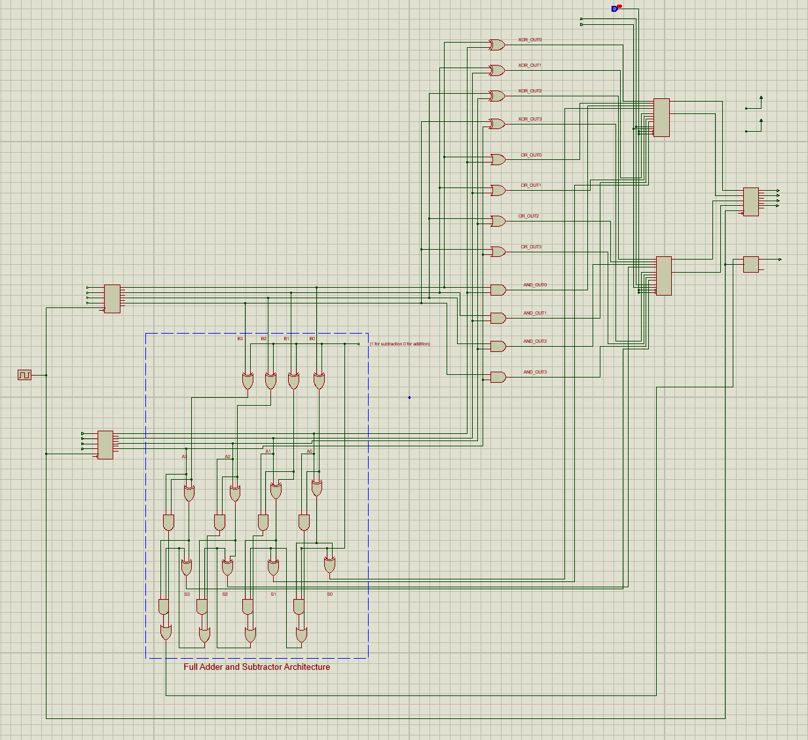

Figure 2: ALU Internal Design.

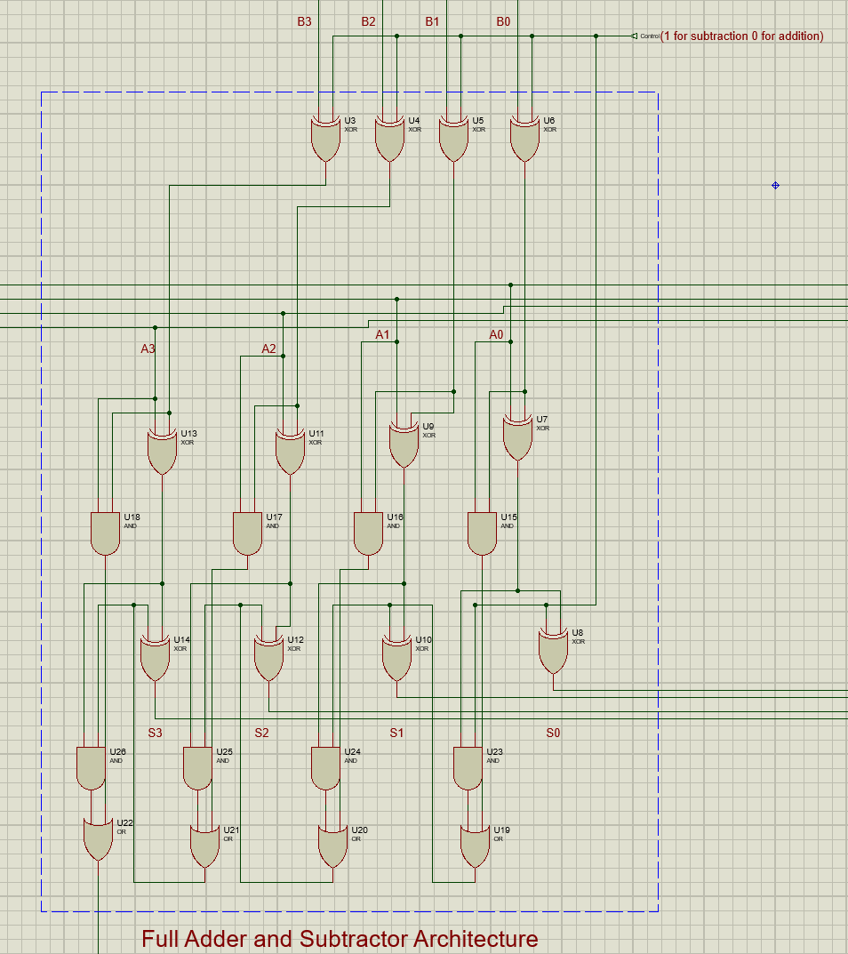

Figure 3: Full Adder/Subtractor Circuit using Generalized Circuit (Full Adder, XOR and Control Signal).

## Test Cases

Figure 7: Addition Case.

Figure 6: AND Case.

Figure 5: OR Case.

Figure 4: XOR Case.

Figure : Subtraction Case.